Past Events

Group Ego Trip 1 - Multidisciplinary Art Exhibition

Oct 2014 - Jan 2015, Brooklyn NY

Special Report: idir Arts Collective, G.E.T. 1 (Group Ego Trip 1) at NYFA
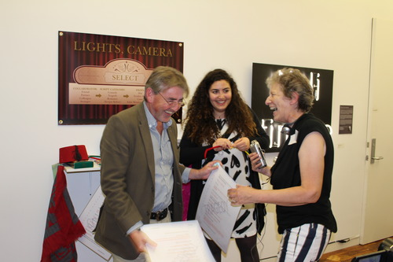
New Feature from the Con Edison Immigrant Artist Newsletter No. 63
Currently on view at NYFA’s gallery is G.E.T. 1 (Group Ego Trip 1), a group exhibition by the Irish-based idir arts collective curated by NYFA’s Director of Programs/Curator, David C. Terry. The artists originally connected at one of NYFA’s Boot Camps that took place in October 2013 with Center for Creative Practices in Dublin, Ireland. After the four day intensive, which focused on the core principles of sustainability, the artists began to meet regularly with some artists living outside of Dublin, who participated virtually. A group crystallized through these meetings eventually formalizing the artist collective idir whose name comes from the gaelic for “between,” signifying collaboration between cultures, between countries and between continents. The collective is the first intercultural and cross disciplinary artist collaborative to come out of Ireland.
NYFA was fortunate enough to have many of the artists come to New York for G.E.T. 1’s opening reception which featured live performances by idir members Alison McKenna, Sinéad Cullen, Frances Mezzetti and Eléonore Nicolas plus a special live appearance by Irish musician Hozier. IAP took the opportunity to speak to the artists about what they learned about exhibiting internationally and about idir, their new arts collective. Below is a summary of this conversation.
idir Chairperson Iris Park spoke about her role in steering the project, how the collective began to implement internal structures, and some of the challenges and surprises along the way: “we have always tried to have a collaborative consensus approach in idir but with such a large group (26 artists) it wasn’t always easy to plan and move forward without a committee in place. The committee was elected at the Annual General Meeting with people voting in person, by Skype, email, and assigning proxy votes. The members were fully engaged in the election process nominating candidates and voting for their preferred choice. I was elected Chairperson using this process and received eighteen votes. We had various subcommittees dealing with different issues with a varied degree of success. We were all learning along the way, learning how to be effective but also learning to work together.
The challenges were immense, we had a disparate group of people with different views, backgrounds, ages, disciplines and yet we had to find a way to work together towards a common goal. The surprises were that when we discussed our work we really gelled, we gave each other ideas, offered a safe place for the artists to experiment and get constructive advice. Our commonality was our creative work and this is where we had our strongest connection.”
Based on her experience with this project, we asked Iris what her top advice would be for an artist or group of artists embarking on an international project, Iris responded: "It is really important to organise the project putting in time scales and nominating people to be responsible for different aspects of the project, for instance funding, shipping, PR, invitations, opening events. It is important to keep abreast of progress in these areas and make sure a timetable is kept. Within a group there will be experience in different areas, the other members of the group can benefit from this experience so the group as a whole becomes more professional. Sometimes the organisation can take over the project and the creative work suffers so a balance must always be sought, after all, it is our creative work which we have to stand over and be proud of. We’re bound to get some aspects of the organisation of the project wrong but we always want our work to be the best it can be.”
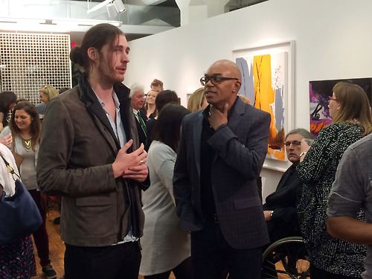
Deepa Mann-Kler, based in Belfast, was one of the artists who often connected virtually to the group. Her neon artwork Noli timere had to be produced in the US. Deepa spoke about the process of manufacturing the piece overseas: “working in neon is challenging and expensive, because you are working with fragile glass therefore it made no sense to risk shipping the work. The next step was to identify a workshop in New York in which I could be confident about the quality of work at a reasonable cost and their ability to deliver to my timetable. This is where working closely with my Belfast neon workshop came in really handy. Being in the trade they were able to recommend three workshops in New York that I approached for quotes. I was very surprised at the variation in price between the workshops and between Belfast and New York. Neon is expensive to work with in Belfast, but it is extremely expensive to work with in New York. Once I had a preferred manufacturer I followed the email communication with telephone calls. It is really important to me that I establish a relationship with people when we are creating and working together. Another helpful factor was knowing that the artwork would be delivered to NYFA, …to get an independent ‘thumbs up’ that it had arrived in one piece and looked great.”
After this experience, Deepa’s top advice for any artist producing work overseas was: “working internationally is very exciting…do your homework and research as much beforehand as you can. I had made an incorrect assumption that neon would be cheaper to manufacture in New York. Secondly it is also really important to have local people on the ground that you can reply upon and trust - for me this was critical to the success of the artwork and the opening night of the exhibition.”
On asking Deepa why she chose Noli timere for this exhibition, she responded: "the theme for idir’s first international exhibition was Group Ego Trip 1 and bearing this in mind, I wanted to create a piece of art that challenged the whole notion of ego - that point at which we pass from this life. Equally I wanted my work to celebrate the links between Ireland and the US. As an Indian woman living in Northern Ireland for the last 18 years, my work often reflects on core themes in the society that surround me, such as politics, music, peace process and now poetry.
Seamus Heaney’s last words were 'Noli timere’; the poet and Nobel Laureate died at the age of 74 on the 30 August 2013, and his son, Michael, recalled that these were written 'in a text message he wrote to my mother just minutes before he passed away, in his beloved Latin and they read, ‘Noli timere’ - ‘don’t be afraid’.’ For me Heaney’s words had the magical effect of shining light into darkness, at a societal, communal and individual level…so to recreate Noli timere in neon endows Heaney’s last message with a fitting luminosity. Neon work is filled with gas that pulses into life and expresses emotion as electricity courses through it. It bursts with optimism and reflects the journey that this farewell text would have taken through the ‘invisible wires’. It was a brilliant stroke of Heaney’s, as a man who lived by his words, to recall the briefest final phrase that could yet only be taken as serious poetic insight.”
One other Noli timere has been made and is now a permanent installation in the Crescent Arts Centre in Belfast. Poetry and book festivals are a regular feature of activity at the Crescent, so it was fitting that Noli timere also found a home here. Deepa said, “I like the idea that there are two Noli timeres - one in Ireland and one in the US - this is in keeping with idir, its origins and our first international show.”
Painter Mary Tritschler spoke of her experience in idir: “the biggest advancement in my practice this year is that by being a member of an arts collective it has empowered me more than I can say! As a member of idir I became very aware of the necessity of having my website, and my CV up to scratch, and of using social media to build our professional profile, it made me strive harder to learn how to use these necessary tools for the good of the group, this in turn reflected in such a positive way on my work. The thrill of seeing my work on exhibition in NYFA and in DUMBO together with my fellow artists taught me to set my sights on a goal and never give up until you achieve it. There is more than one way to that end, for some it’s the front door for others it’s through the Scullery window!!! Who cares just go for the back of the Net!!!! That Goal! “
Multi-disciplinary artist Eléonore Nicolas originally from France, talked about the experience of performing live: “I felt very privileged to be part of the first idir exhibition Group Ego Trip 1 at the New York Foundation for the Arts and even more privileged to be able to ask the whole audience at the opening to get together and clap for three minutes non-stop to create the video Well Done You’re Brilliant. I did find that working 5000km away from home was a bit unsettling at first and I was happy to be exhibiting as part of the Irish based group idir as the support of the group definitely gave me more confidence to set up the performance in New York." Click here to view the New York performance, and as the artist notes; "A daily intake of Well Done You’re Brilliant is recommended for an ego boost!”
If you’re interested in knowing more about the artists on view, NYFA’s gallery is open Monday – Friday, 9:30 AM – 5:30 PM. To meet the artists in person, please join us on January 16, 6:00 PM – 9:00 PM for a night of musical and literary performances by idir members Dave Rock and Brian Horgan. Connect virtually with idir via @idirartists, Facebook and online.
Participating Artists: Mathias Baumann, Raine Hozier Byrne, Anne Crossey, Sinéad Cullen, Jo Cummins, Gavin Hogg, Brian Horgan, Jackie Hudson Lalor, Daire Irwin, Seanán Kerr, Kirsti Kotilainen, Deepa Mann-Kler, Alison McKenna, Frances Mezzetti, Eleonore Nicolas, Inez Nordell, Seán O’Dwyer, Geraldine O’Sullivan, Mary O’Sullivan, Nuala O’Sullivan, Iris Park, Dave Rock, Sandra Schoene, and Mary Tritschler. Special thanks to our generous supporters: Culture Ireland and Centre for Creative Practices.
Are you currently receiving NYFA’s free Con Edison Immigrant Artist Newsletter? Sign up to receive the monthly email featuring artist interviews, special reports, and upcoming arts deadlines and professional development resources.

Images, from top: Opening Reception: G.E.T. 1 (Group Ego Trip 1): NYFA’s offices, Artist Iris Park on far right; David Terry, Director of Programs and Curator with musician Hozier. Photography by Jennifer Catton and Nuala O’Sullivan.

Summary of launch night
A week ago, on October 9th, #idir arts collective and #NYFA with Culture Ireland had invited you all to join us for the opening night of "Group Ego Trip 1".
Please find below a summary of the evenings' programme and speakers.
First things first, idir would like to extend their heartfelt thanks to all guest speakers. Thank you for joining us in this “adventure”.
Our MC and host for the night was no other than, David C Terry, Director of Programs and Curator at New York Foundation for the Arts, Visual Artist who also curated our exhibition. Special thanks for coming along on this journey with us, David.
Speeches were delivered as follows.
Michael Royce, Executive Director of the New York Foundation for the Arts.
Ambassador David Donoghue, Irish Ambassador to the United Nations, in attendance with his wife Jill.
Fiona McCabe, Vice Consul, Consulate General of Ireland in New York, Department of Foreign Affairs.
Iris Park, idir Chairperson
The speeches were followed by a number of performances. Titles and artists listed below in chronological order.
1. Alison McKenna performing in Iris Parks’ “Do You Know Who I Am”, a sample excerpt. The whole piece can be watched as an installation at the exhibition.
2. Sinead Cullen and Frances Mezzetti performed “Now”, an improvised sound and movement piece incorporating the collaborative element of idir.
3. Eleonore Nicolas engaged the audience in her piece “Well Done, you're brilliant!” which was recorded and will be available online soon.
Special Guest - Hozier
performing unplugged "In a week" featuring Allanah Henderson as well as his number one hit "Take me to Church".
What a treat that was! :)
idir would like to thank everyone for their support, help and advice in particular The New York Foundation for the Arts (NYFA) and Culture Ireland. Also the idir artists, their families,friends and supporters who travelled to New York to make the opening such a special event.
Thank you to our Facebook followers and everyone who couldn't attend but was there in spirit. x
Please continue to spread the word about us and exhibition.
Exhibition is running until 30th January 2015, Gallery open Mon – Fri 9.30am to 5.30pm.
New York Foundation for the Arts, 20 Jay Street, 7th floor, Dumbo, Brooklyn 11201, NY.

Brooklyn Group Show Grown Out of NYFA Bootcamp in Ireland
NYFA invites you to join us for G.E.T. 1 (Group Ego Trip 1), a group exhibition by the Irish-based idir Arts Collective curated by NYFA’s Director of Programs/Curator, David C. Terry.
Formed by twenty-six participants from the 2013 Bootcamp in Dublin, Ireland, the name idir is from the gaelic for ‘between’…signifying collaboration between artists, between cultures, between countries and continents.
Reception: Thursday, October 9, 6-9 PM
Exhibition Dates: October 9, 2014 - January 30, 2015
Gallery Hours: Monday - Friday, 9:30 AM- 5:30 PM
Free and Open to the Public
Location:
New York Foundation for the Arts (NYFA)
20 Jay Street, Suite 740
Brooklyn, NY 11201
(Closest train is the F to the York Street station)
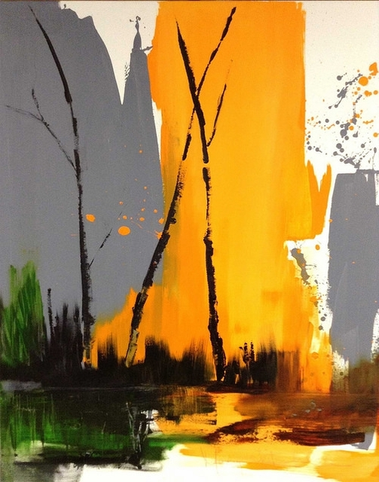
Participating Artists
Mathias Baumann, Raine Hozier Byrne, Anne Crossey, Sinéad Cullen, Jo Cummins, Gavin Hogg, Brian Horgan, Jackie Hudson Lalor, Daire Irwin, Seanán Kerr, Kirsti Kotilainen, Deepa Mann-Kler, Alison McKenna, Frances Mezzetti, Eleonore Nicolas, Inez Nordell, Seán O'Dwyer, Geraldine O'Sullivan, Mary O'Sullivan, Nuala O'Sullivan, Iris Park, Dave Rock, Sandra Schoene, and Mary Tritschler
Click here for more information about NYFA’s boot camps for artists and/or arts administrators.
Click here for more information about NYFA’s Curatorial Services for organizations, corporations, and individuals.
Special thanks to our generous supporters: Culture Ireland and Centre for Creative Practices.

idir - Launch Event & Multidisciplinary Art Exhibition

18th September 2014, Trinity Innovation Academy, Dublin

